COURSE CODE/TITLE: | CPE 010 |  | SECTION: | CPE21S3
DATE PERFORMED: | 7/23/26 |  | DATE SUBMITTED: | 7/28/26
NAME: | Ralf Nicolo B. Abello |  | INSTRUCTOR: | Engr. Jimlord Quejado

ACTIVITY NO. 3.1 | Linked Lists
1. PROCEDURE OUTPUT
Screenshot | 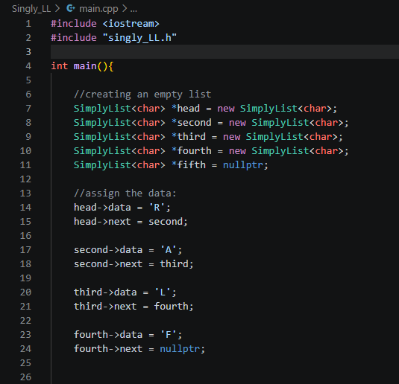
Discussion | I built this as a starter singly linked list using a SimplyList<char> template, with a separate singly_LL.h header holding the class definition. I declared four node pointers, head, second, third, and fourth, and allocated each with new, then set fifth to nullptr since I didn't end up using it.  I manually set each node's data and next by hand, linking head to second, second to third, and third to fourth, spelling out my name "RALF." fourth->next is set to nullptr to properly terminate the list. This is the same manual wiring approach as the example at the manual ‘CPE010’ , so it still has the same limitation, it only works because I hardcoded four separate pointers, and it wouldn't scale to a longer list without writing a reusable insertAtEnd() function instead.
Table 3-1. Output of Initial/Simple Implementation

Operation | Screenshot
Traversal | 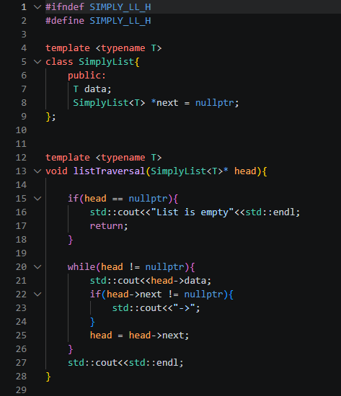
Insertion at head | 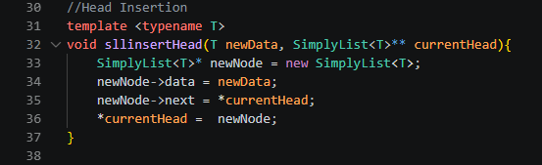
Insertion at any part of the list | 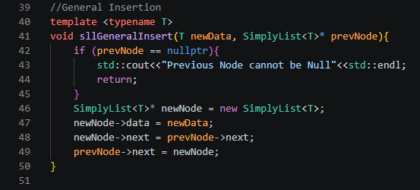
Insertion at the end | 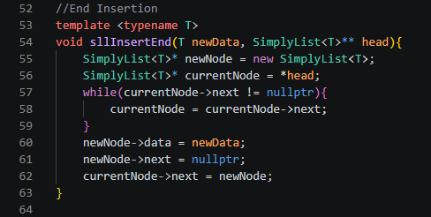
Deletion of a node | 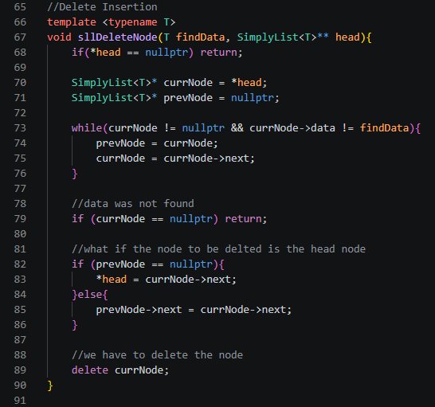
Table 3-2. Code for the List Operation

a. | Source Code
a. | Console | 
b. | Source Code
b. | Console | 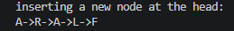
c. | Source Code | 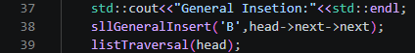
c. | Console | 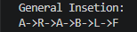
d. | Source Code | 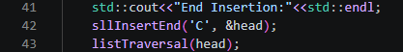
d. | Console | 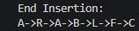
e. | Source Code | 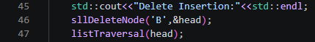
e. | Console | 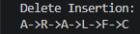
f. | Source Code | 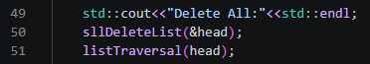
f. | Console | 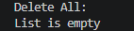
Table 3-3. Code and Analysis for Singly Linked Lists

Screenshots(s) | Analysis
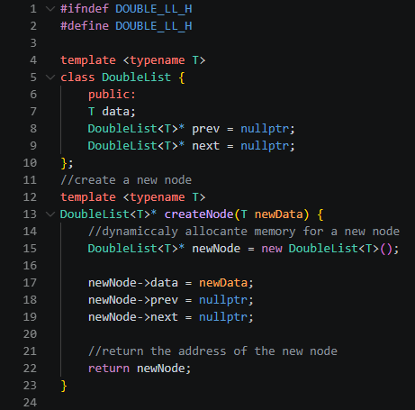  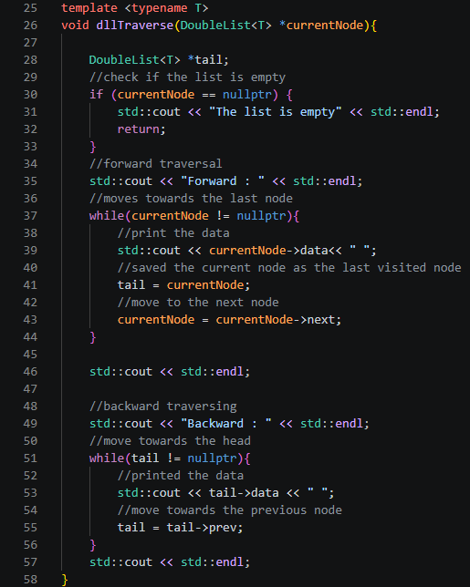 | DoubleList<T>  I made this templated so it works with any data type, not just char. Each node holds data, plus prev and next pointers that default to nullptr when declared. This way every node starts off safely linked to nothing instead of pointing to garbage memory.  createNode()  I allocate a node on the heap and set prev/next to null before returning its address. This keeps node creation separate from node linking, so I can reuse this same function inside every other operation instead of repeating the setup code each time.  dllTraverse()  I do a forward pass first, printing while moving through next and saving the last node visited into tail. Then I go backward using that same tail, moving through prev until I reach the front again. This two-direction traversal is the whole point of using a doubly linked list instead of a singly linked one, since a singly linked list has no way to walk backward.
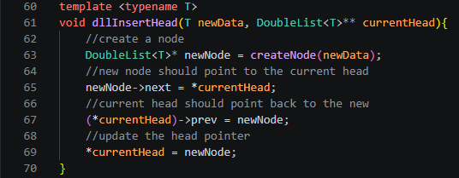 | dllInsertHead()  I create a node, point it forward to the current head using newNode->next, then point the old head's prev back to the new node so the link works both ways. After that I update the head pointer itself so it now points to the new node.
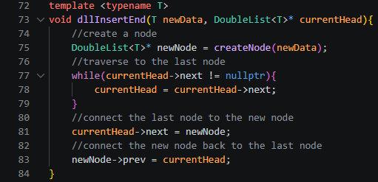 | dllInsertEnd()  I move currentHead forward using a loop until I hit the node whose next is null, meaning I've reached the last node in the list. Then I link the new node in both directions at once, connecting currentHead->next to the new node and newNode->prev back to the old last node.
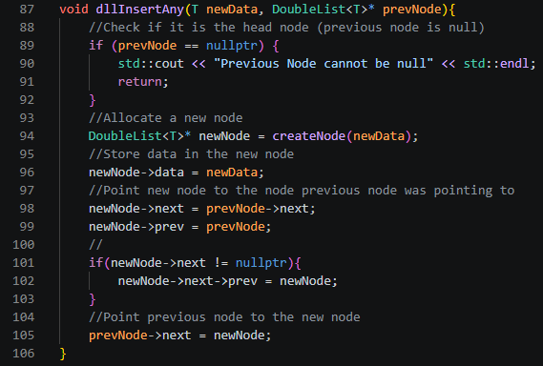 | dllInsertAny()  I check for a null prevNode first, then make the new node and relink both neighbors around it. That means setting the new node's own next and prev, and also fixing the node that comes right after it using newNode->next->prev = newNode, so the chain stays connected on both sides instead of just one.
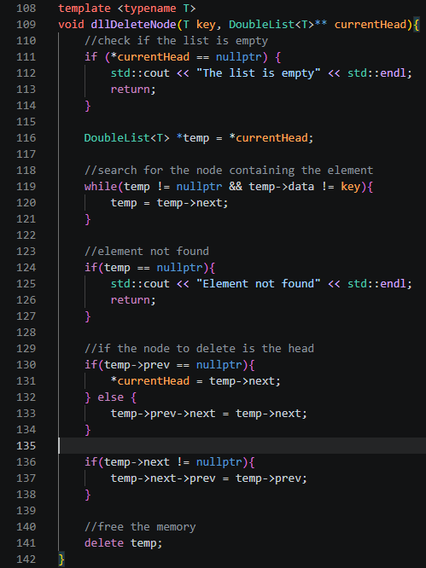 | dllDeleteNode()  I search through the list for the node matching the given value, then check whether it's the head node using temp->prev == nullptr. Depending on the answer, I relink whichever neighbors actually exist around that node, then free its memory with delete temp so there's no leftover allocated memory once it's removed.
Table 3-4. Modified Operations for Doubly Linked List

2. ANSWERS TO SUPPLEMENTAL ACTIVITY
Main.py:
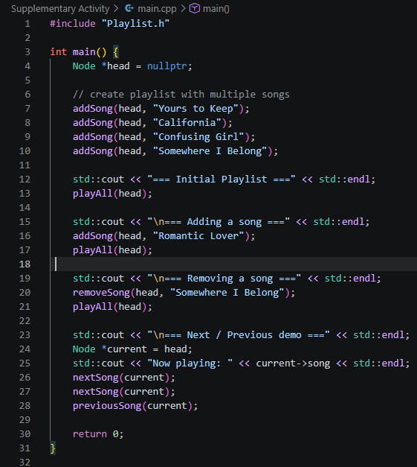

Playlist.h:
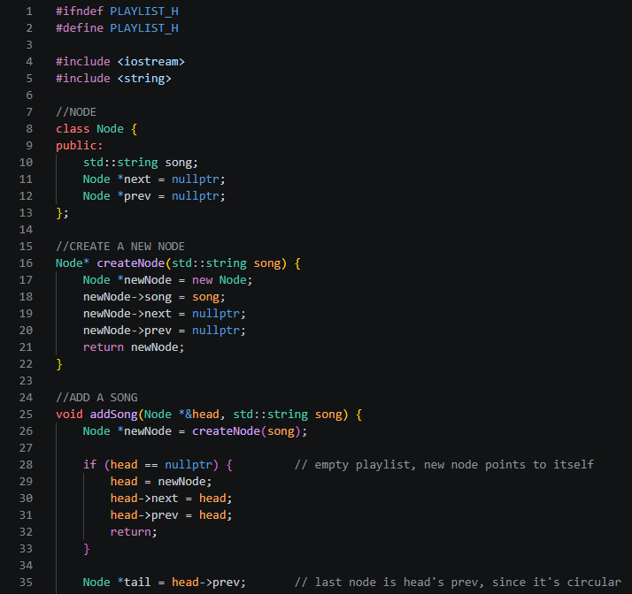
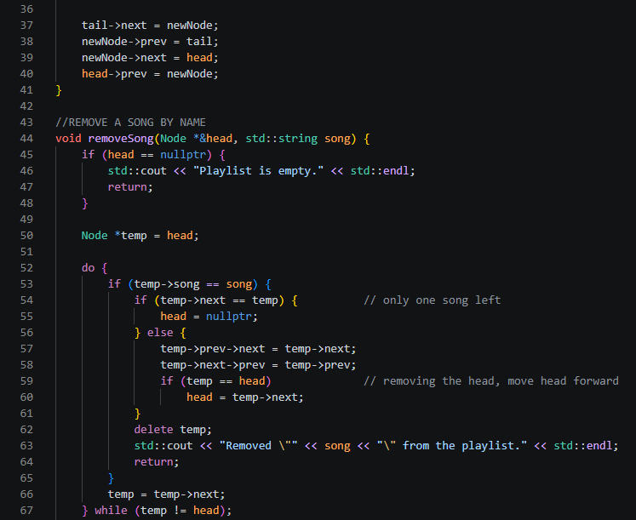
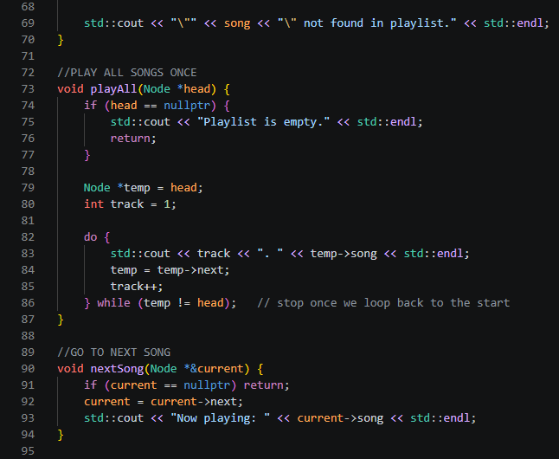
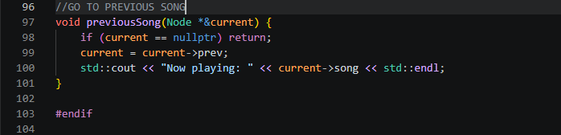

Output:
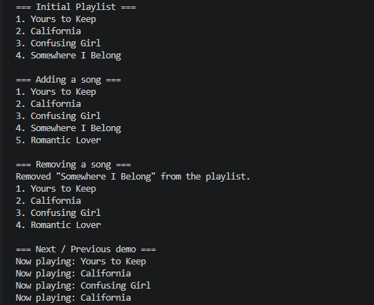

Code Analysis:
I built this playlist as a circular doubly linked list, split into a header file and a driver file so the logic and the demonstration are separated the same way a the procedure would organize them. The Node class stores the song title as a string instead of the char I used in my earlier singly and doubly linked list work, along with next and prev pointers that default to nullptr. createNode() handles allocation the same way it did before, keeping "make a node" separate from "link a node" so every other function can reuse it instead of repeating the same setup code. What actually makes this list different from my previous doubly linked list is that it has no nullptr ending at all. Instead of the last node's next pointing to null, it points back around to head, and head's prev points to the last node instead of null too. That closed loop is the entire reason this structure works for a music player, since a real playlist doesn't just stop after the last song, it needs to be able to keep going in either direction indefinitely, which is exactly what a circular shape allows and a straight line of nodes can't.
In addSong(), I find the tail through head->prev instead of walking the whole list with a loop like I would in a normal linked list, since in a circular list the tail is always sitting right there attached to the head, so I can just grab it directly and save a full traversal. Both removeSong() and playAll() use a do while loop instead of a regular while, and this matters a lot here specifically because a circular list has no natural stopping condition like a nullptr check, so if I used a normal while(temp != nullptr) it would loop forever. The do while structure lets the loop run at least once and then checks afterward whether temp has made it all the way back to head, which is what actually stops the traversal at the right point. removeSong() also has to account for two situations that don't come up in a non-circular list: deleting the only remaining song, where the node effectively points to itself and the whole list needs to become empty, and deleting the head node specifically, where I have to move the head pointer forward to the next node before the original head gets freed, otherwise the list would lose its entry point entirely. Lastly, nextSong() and previousSong() end up being the simplest functions in the whole file precisely because the list is circular, since moving through next or prev never risks hitting a null pointer. Reaching the last song and calling nextSong() just wraps back around to the first one automatically, and the same thing happens in reverse with previousSong(), so neither function needs any bounds checking at all.

Conclusion:
This activity helped me understand how linked lists actually work, since building the singly linked list first showed me how tedious and error-prone manual node wiring is without reusable functions like insertAtHead and deleteNode, and moving on to the doubly linked list taught me that the real challenge isn't a new concept, it's remembering to update that extra prev pointer on every single operation. Working through the procedure step by step, from the initial hardcoded CPE010 example to inserting and deleting specific elements, helped me see why the logic changes depending on whether I'm working at the head, the middle, or the end of the list. The supplementary playlist activity pushed that further by having me apply the same ideas to a circular doubly linked list, where I had to rethink my traversal and deletion logic completely since there's no nullptr to stop at, and specifically account for edge cases like removing the last song or removing the head itself. Overall, I think I handled the core list operations well across all three types, and going forward I want to get more comfortable writing these structures from scratch without leaning as much on a reference implementation.

3. ARTIFICIAL INTELLIGENCE (AI) USE DISCLOSURE STATEMENT
I hereby declare that artificial intelligence (AI) tools were used, if applicable, in the preparation of this academic work. The following indicates the nature and extent of AI assistance:

Tools Used: | ChatGPT & Grammarly
Examples: ChatGPT, Microsoft Copilot, Grammarly, QuillBot, etc.

Purpose of Use: | Grammar correction & code assistance
Examples: grammar correction, idea generation, formatting, summarization, code assistance, explanation of concepts, etc.

Extent of Use: | Learn how circular list worked and how to implement it on the activity
Explain how AI was used and confirm that it did not replace original thinking, analysis, authorship, or completion of the required work.

By submitting this activity, I affirm that my use of AI complies with T.I.P.’s AI usage policy and does not exceed the permitted limits for similarity, automated content generation, or academic assistance.

I understand that any false, incomplete, or misleading disclosure may be subject to investigation in accordance with due process and may result in sanctions for violation of existing T.I.P. policies.

Lab activities, templates, and related instructional materials shall not be reuploaded, reproduced, distributed, or shared with external organizations or third parties without the prior express written permission of the Technological Institute of the Philippines.

